**Working with worksheets**

**Introduction**

You may be familiar with managing rows and columns to organize worksheets efficiently. However, there are many techniques that you can use to organize other elements of your workbooks like **tabs** and **sheets**.

By the end of this reading, you’ll be able to:

* Rename and recolor worksheet **tabs**.
* Organize the workbook by hiding, unhiding, and reordering **sheets**.

**Working with worksheets**

**Renaming sheets**

Using descriptive names on your worksheets can help users locate them quickly. By default, all **sheets** in a workbook are named sequentially as **Sheet1**, **Sheet2**, and so forth. These sheet names are displayed on **tabs**. **Tabs** are located at the bottom of the Excel screen, outside of the worksheet cells area, and just above the status bar.

To rename a worksheet double-click a worksheet **tab**. This action highlights the existing name. Type the name and press **Enter**.

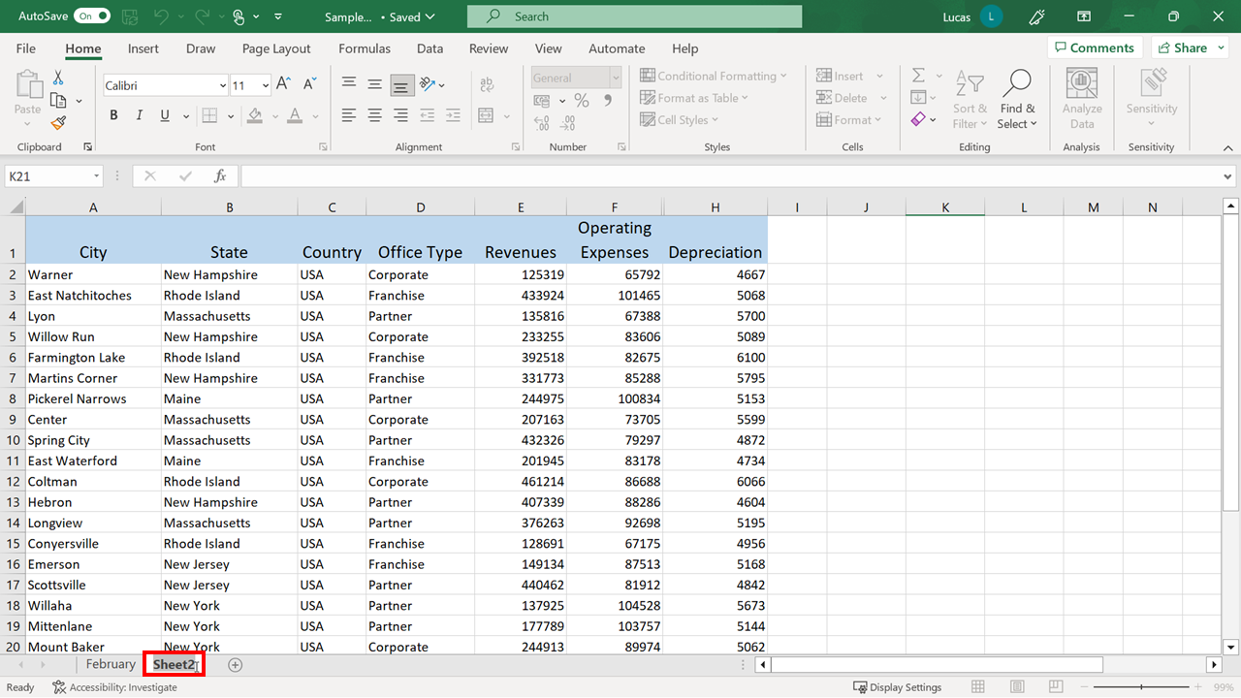

**Recoloring tabs**

Applying color to a worksheet **tab** helps readers to locate and identify it. Using the same color on multiple worksheets indicates that the content is related. To change the color of a worksheet **tab**, right-click the worksheet **tab**, choose **Tab Color** from the shortcut menu, and then select a color from the palette.

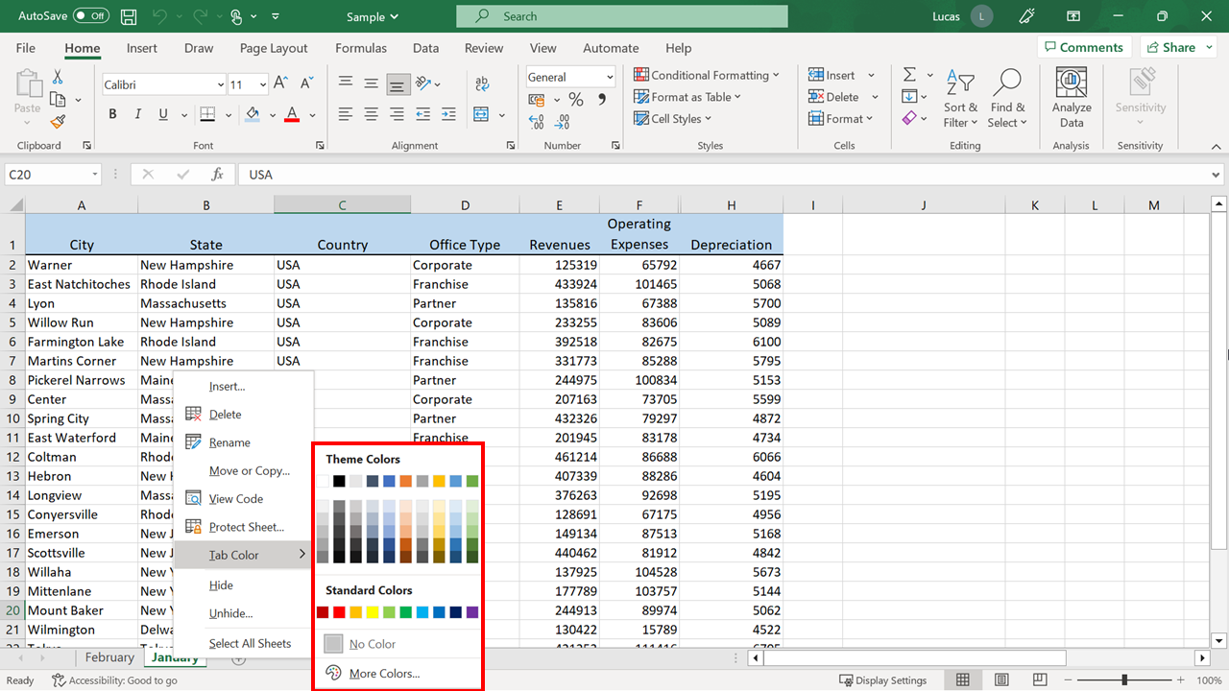

To remove a color, select the **Tab Color** menu. Then choose **No Color**.

**Inserting and deleting worksheets**

You can organize your workbook data more effectively by spreading it across multiple worksheets. To quickly insert a new worksheet, select the **+** icon on the right of your **sheet tabs**.

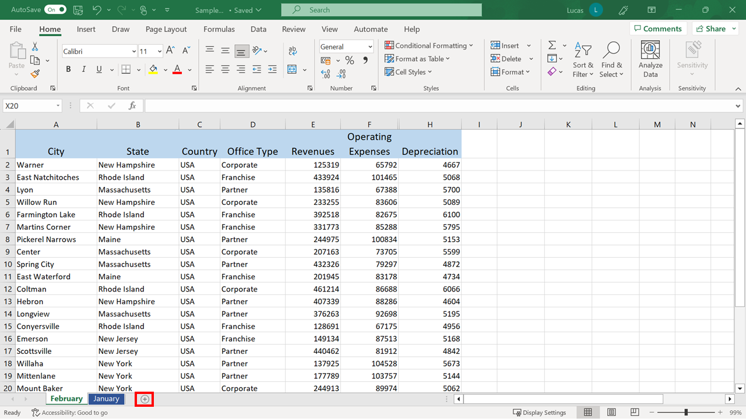

Excel immediately creates a new blank worksheet.

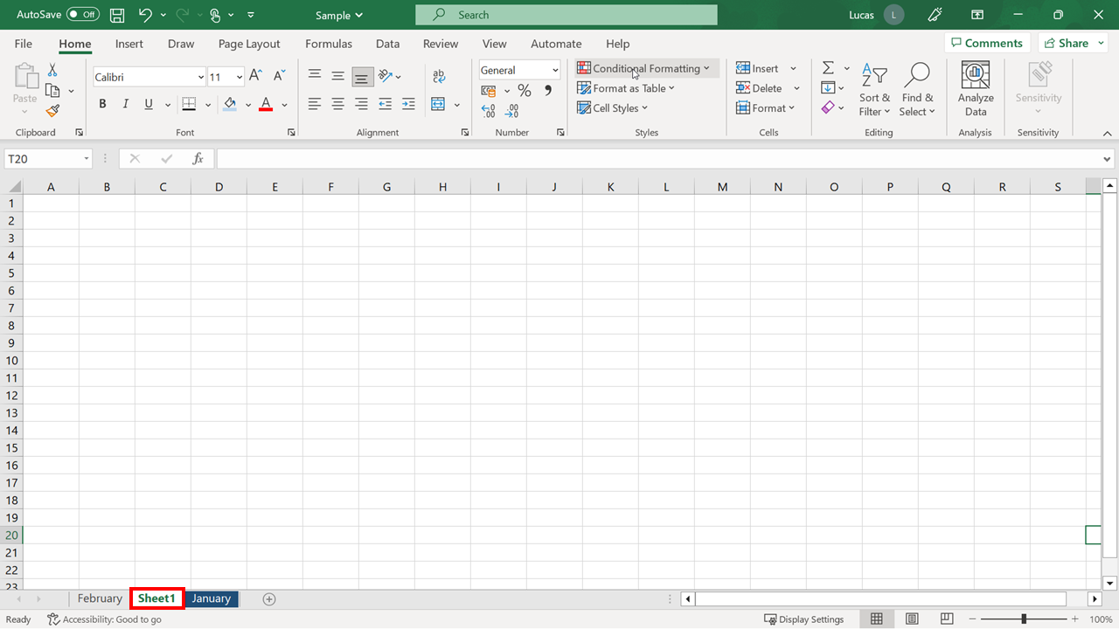

To delete a worksheet, right-click the **tab** for that worksheet and choose **Delete** from the list of options.

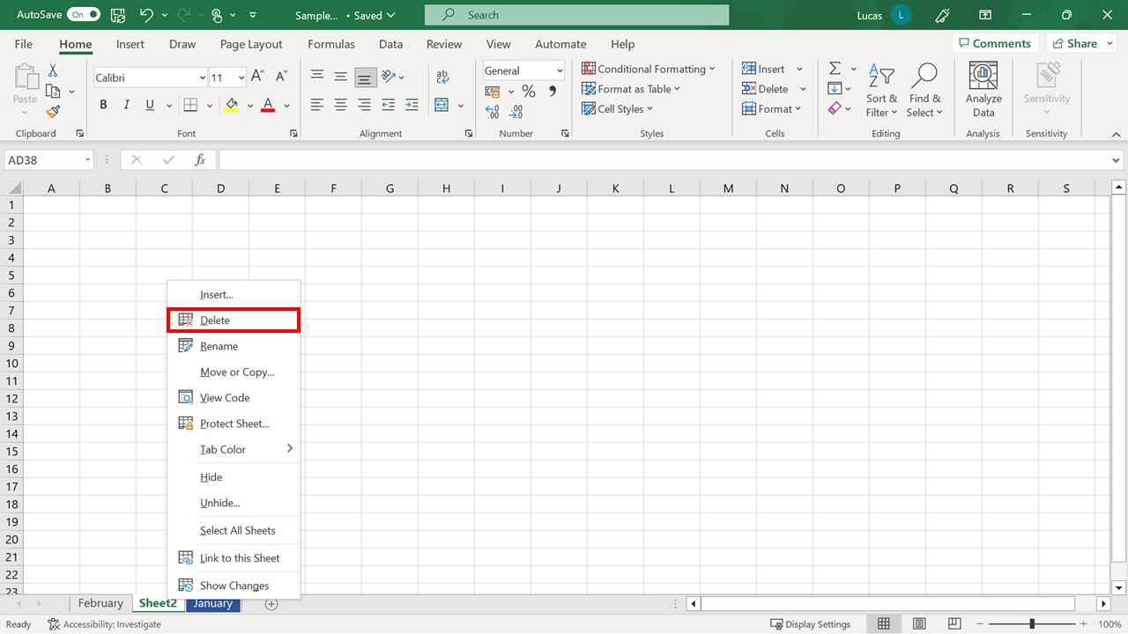

The **Undo** feature cannot reverse the deletion of a worksheet. If the worksheet contains any content, a warning dialog box appears during the deletion process, requesting confirmation to delete the selected worksheet. Select **Delete** to complete the sheet deletion process.

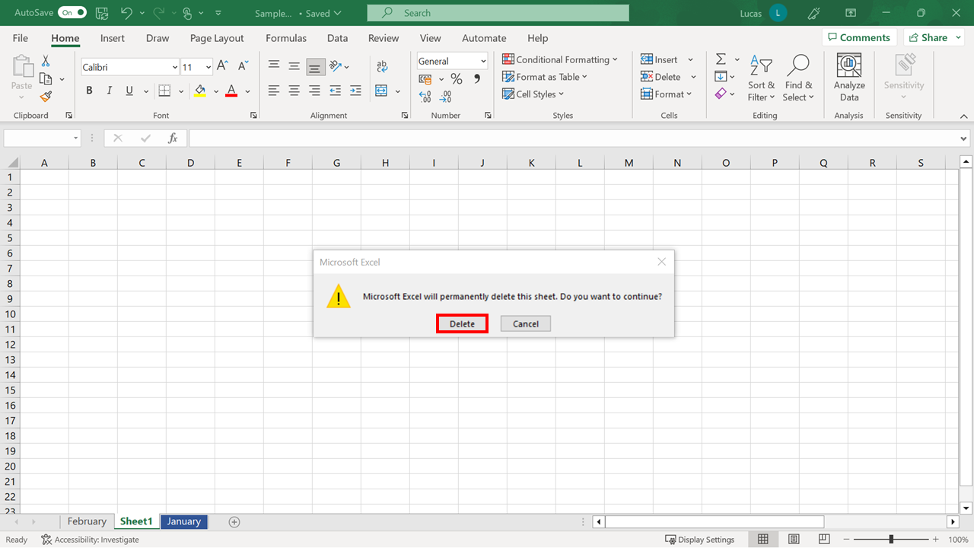

**Duplicating a sheet**

What if you need to alter the contents of a worksheet but also preserve the original data? In this instance, you could create a copy of the original worksheet. To create a copy of a worksheet, right-click its **tab** to bring up the options. Then select the **Move or Copy** option. In the **Move or Copy** dialog, tick the **Create a copy** box and select **OK**.

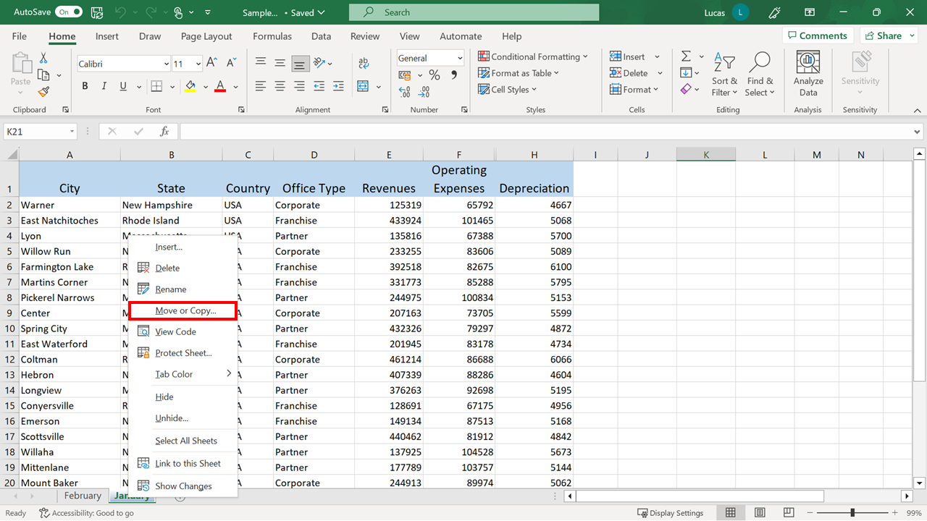

Excel creates a copy of the worksheet with all its original content.

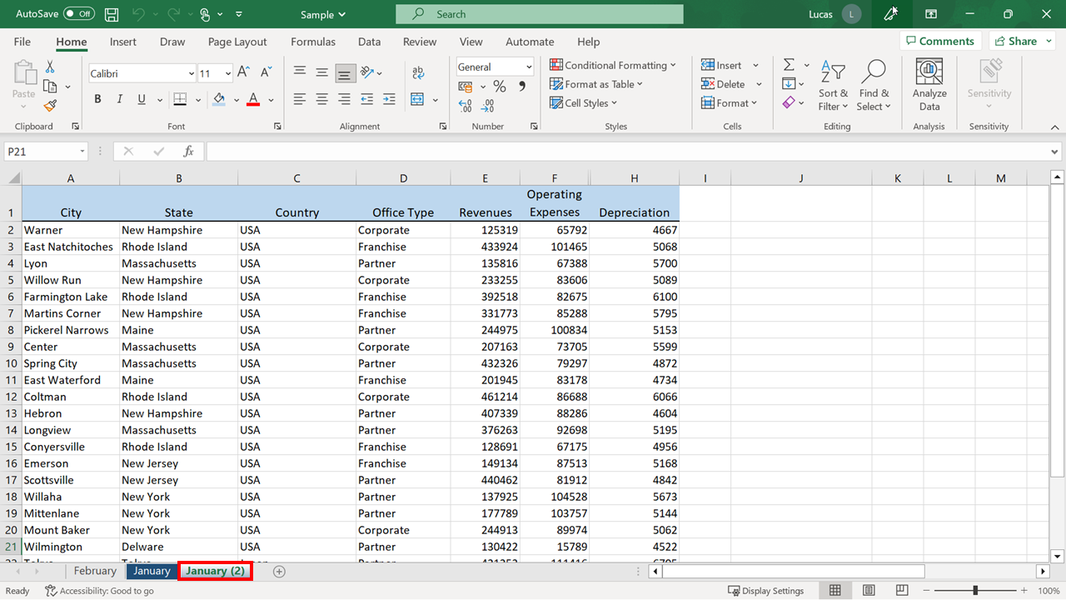

**Reordering sheets in a workbook**

Positioning sheets in a workbook in a clear, logical order can help users understand the data flow. The quickest way to reposition a worksheet is to select and drag the worksheet **tab** to a new location in the sheet sequence.

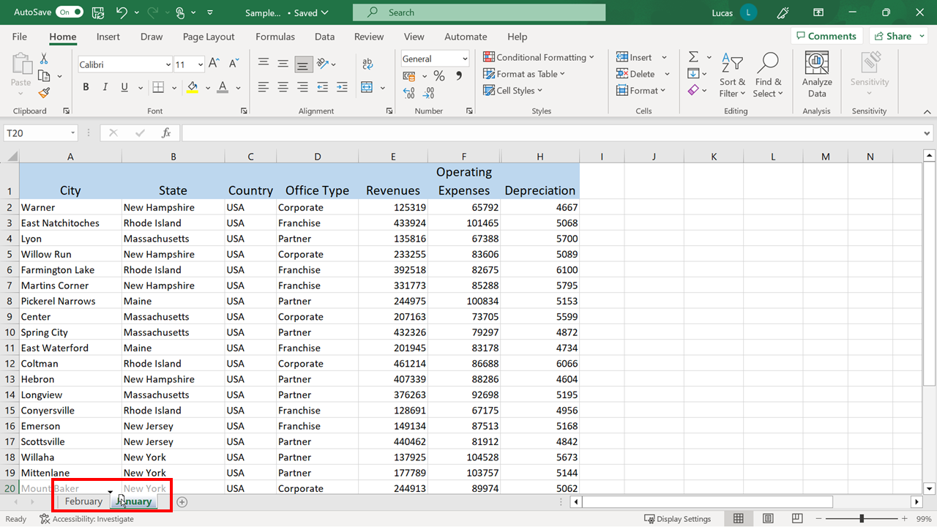

Once you have positioned your mouse to where you want to move your **sheet**, you can release the mouse button to complete the operation.

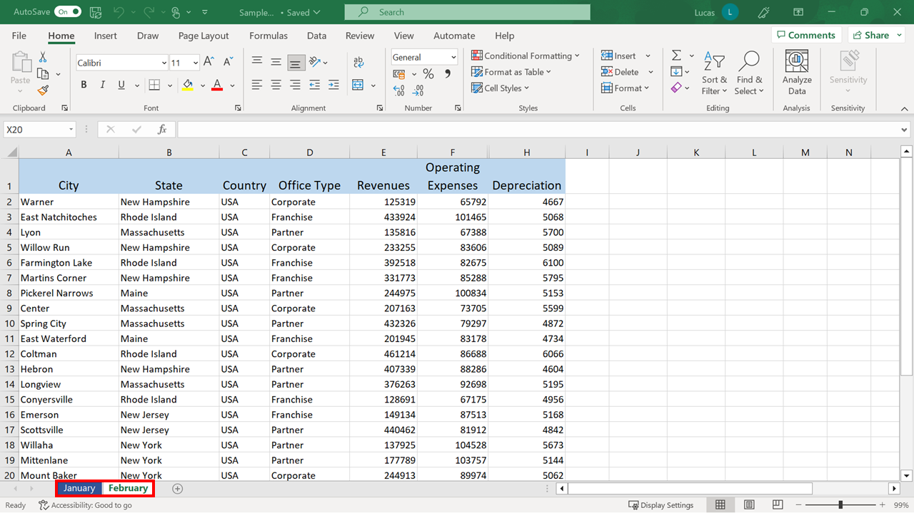

Dragging sheets within a workbook containing many worksheets can be difficult. So, an alternative method is to right-click the worksheet **tab** and choose the **Move or Copy** option.

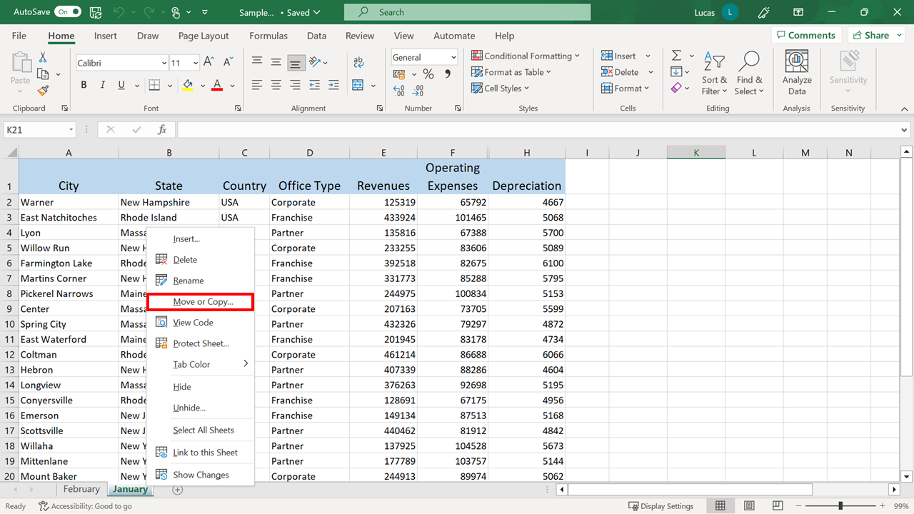

When the **Move or Copy** dialog opens, choose a new position and select **OK**.

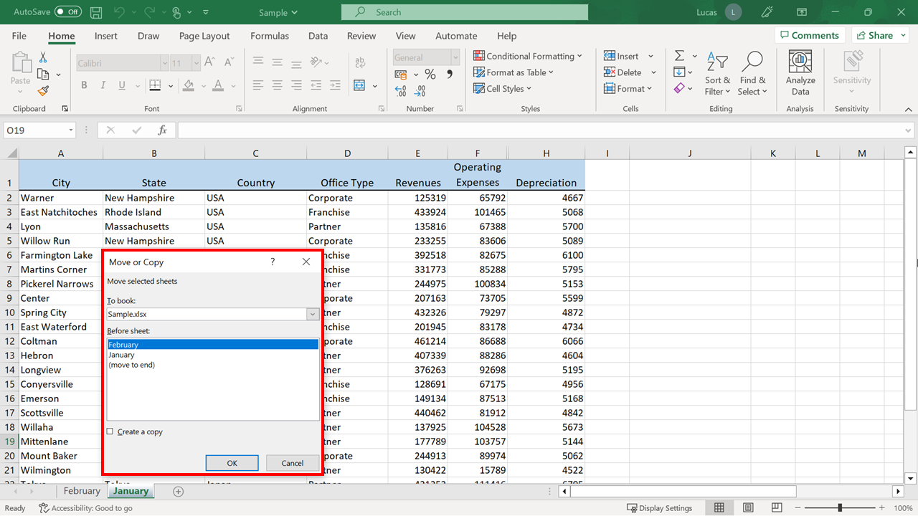

**Conclusion**

In this reading, you reviewed a range of techniques for organizing workbook **tabs** and **sheets**. You should now know how to use these techniques to organize content efficiently.